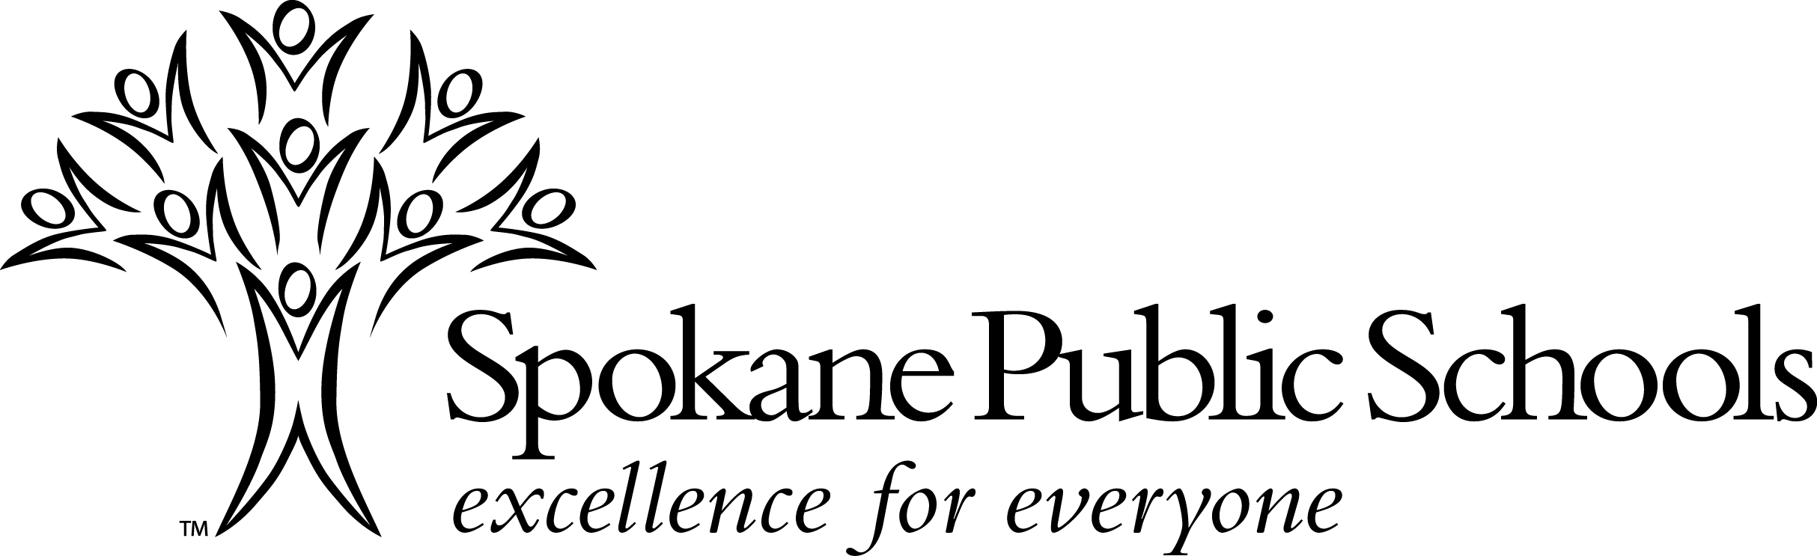

High School Activity Agreement

School programs should reflect the attitudes of the community which support them. If the community is to truly identify with its schools through the activities program, it is imperative that team members dress and behave in a manner which will inspire pride and approval by the community. Also, if students are to derive appropriate benefits from activities and/or programs, they must be able to operate in a climate free of disruptive behavior.

Developing and maintaining a positive school/team spirit must be based on the creation of an appropriate atmosphere and fair discipline standards. Clearly, appropriate rules and regulations are necessary for this positive atmosphere to be maintained.

These rules and regulations apply to each student who participates during the defined activity season which begins with the first practice/tryout or the first day of the term of office, and concludes with the awards presentation for that activity.

Definition of Activities

Because activities are an extension of the school day, students represent their school as a participant in those activities. Students are reminded that participation in activities is a privilege. Included in this agreement are all Associated Student Body (ASB) activities and school athletic teams.
Eligibility

All Washington Interscholastic Activities Association (WlAA) eligibility requirements, including the following, must be met by participants:
• A student shall be under 20 years of age on September 1 for the fall sports season, on December 1 for the winter sports season, and on March 1 for the spring sports.
• Parents or guardians are bona fide residents of Spokane Public Schools.
• In attendance the previous semester.
• Pass a physical examination (if required). Updated every two years.
• Absence for one or more periods on the day of contest/practice requires permission of principal/designee prior to participation.
• WIAA and Spokane Public Schools require students maintain passing grades in a minimum of five (5) full time subjects. Grades will be checked a minimum of 4 1/2 weeks at mid-quarter, quarter, and semester. Students who are not passing at least five (5) classes at mid-quarter and quarter will be declared ineligible until they have met this standard. Students not passing at least five (5) classes at the conclusion of first semester will be declared ineligible for the first five (5) weeks of second semester. Students not passing at least five (5) classes at the conclusion of second semester will be declared ineligible through the fourth Saturday in the Fall. Students can practice but may not participate in contests, events, or activities while academically ineligible.
• Grade status at mid-quarter and quarter will be determined by the grade listed in the semester column of PowerSchool (S 1 or S 2).
• The opportunity for an academic improvement plan will be provided by teacher(s) and the coach/advisor working with the student.
• Individual schools may adopt stricter academic guidelines provided notice is given to students and parents of these guidelines.
• Students become ineligible one week from the District determined mid-quarter and quarter progress report date.
• A teacher may give a student a (P) passing grade at the progress report date if the student is making progress toward standard.

RULES AND REGULATIONS

Regulations Regarding Drug (including Marijuana), Alcohol, and Tobacco Use:
• A participant shall not possess, use, deliver, distribute, sell, offer to sell, be under the influence of, or show evidence of having used or abused any controlled substance, counterfeit substance or any illicit drugs, marijuana, alcohol, or tobacco. (For the purpose of this policy, the term “tobacco” shall include, but is not limited to, cigarettes, cigars, snuff, smoking tobacco, smokeless tobacco, nicotine, vapor/electronic smoking devices, unapproved nicotine delivering devices, chemicals or devices that produce the same flavor or physical effect of nicotine substances; and any other smoking equipment, material or tobacco innovation.)
• It is the expectation of students as leaders and role models that they not attend parties where alcohol or drugs are being used by minors. Students need to have the courage and self-discipline to leave immediately, and if they choose not to, they will be held in violation.

Penalties Regarding Drugs (including Marijuana), Alcohol, and Tobacco:
• Within an entire high school career while under any activity agreement, the following penalties apply:
⇒First Offense:
- The student will be ineligible immediately and will be suspended from the sport or activity or sport season for 14 calendar days and until the successful completion of a district approved education intervention program. The 14 days begin at the time of self-report to the coach/administrator or on the day the discipline is imposed. Participation in any subsequent sport or activity is dependent upon completion of a district approved education intervention program.
- During the suspension, if the student is participating in the educational intervention program, the student athlete may practice but may not participate in contests, events, or activities.
- Students will be allowed only one "first offense" during the entire high school career.
⇒Second Offense:
- The student will be ineligible for participation in all identified activities for a period of one calendar year from the date the discipline is imposed.
⇒Third Offense:
- Ineligibility for the remainder of the student's high school career.

Legend Drugs and Controlled Substances:
The use of legend drugs/anabolic steroids and controlled substances is penalized through Washington State Law RCW 69.41.050 and RCW 69.50. On the first violation, the athlete is ineligible for the remainder of the season. On the second violation, the athlete is ineligible for one calendar year. On the third violation, the athlete is permanently prohibited from participation.

Social Media Rules & Regulations:
Specifically prohibited behaviors include but are not limited to transmission of:
- Sexually explicit, profane, lewd, indecent, illegal, or defamatory language/actions.
- Derogatory language regarding school personnel or other students.
- Comments designed to harass or bully students and/or school personnel.
- Nude, sexually-oriented or indecent photos, images or altered pictures.
Also prohibited are all on-campus connections to off-campus violations of the policy:
- Use of school computers to view off-campus postings.
- Students accessing posts at school on their own devices.
- Distribution of hard copies of posts on school property.
- Re-communication on campus of the content of the posts.
Violations of the social media rules and regulations may result in suspension from the team or removal from the team on the first offense. Student-athletes who fail to adhere to these rules and regulations may also be subject to additional penalties imposed by Spokane Public Schools.

Other Rules and Regulations:
• All students participating in activities are required to comply with all rules and regulations contained within board policy and procedure 3200.
• A participant shall not engage in conduct detrimental to the team or to the school.
• A participant shall not use obscene or vulgar language.
• A participant shall not steal or use another's property without permission.
• A participant is expected to attend all scheduled practices, meetings, contests, and performances whether school is in session or not. If it is necessary to be absent, prior arrangements must be made with the coach/advisor.
• A participant is responsible for school-owned equipment checked out to him/her. The participant will assume the financial obligation due to loss or misuse of this equipment.
• A participant is expected to travel to and from contests, performances or activities with the team when transportation is provided for this purpose. Only on the personal request by a parent/guardian of the participant and with approval of the principal/designee will this regulation be waived.
• A participant is expected to adhere to all other rules which are unique to a particular activity.

Penalties for Violation of Other Rules and Regulations
• Violation of the rules and regulations may result in discipline by the coach, advisor, director, etc.
• Awards may be forfeited.
• Violation of the rules and regulations may also be the basis for school discipline, suspension, or expulsion from curricular subjects and/or courses pursuant to Student's Rights and Responsibilities, Policy 3200.

GRIEVANCE PROCEDURES
A student removed from an activity shall be entitled to use the informal grievance procedures as outlined in Board Procedure No. 3200, Section E.
I have read and understand the above rules, regulations and penalties.

Parent/Guardian Signature Date Student Signature

*Falsifying information or signatures on any required activity form may be cause for loss of eligibility for one calendar year.

Form 62-0071 Rev. 6/14

